***Project title:***

**Home Automation**

***6 authors including:***

Muhammad Sheharyar(B16101146) 

MUHAMMAD SALMAN(B16101110) 

M.Maaz Uddin Khan (B16101104) 

MUHAMMAD HAMZA (B16101093)

MUHAMMAD SUFYAN (B ) 

M. Waleed Khan (B16101122) 

M. Bashir Uddin (B16101087) 

***Abstract:***

Home automation systems have gained popularity in recent years, paralleling the advances in the concept of the Internet of Things. The current project presents the implementation of an inexpensive home automation system, within the framework of assistive technology. The system implementation is based on the Arduino microcontroller, with Bluetooth communications capability, and it is designed for use by the elderly and people with disabilities. The system is user-friendly, with an intuitive interface implemented on an Androidbased smart phone. Demonstrations show that the system facilitates control of home appliances, lights, heating, cooling systems and security devices by the intended users, i.e., the elderly and the disabled.

***Introduction:***

Home automation is becoming more and more popular day by day due to its numerous advantages. This can be achieved by local networking or by remote control. Our Aim is to design a kit that can be used for controlling AC Loads from Android phone by using Arduino as microcontroller. Home automation refers to the use of computer and information technology to control home Appliances and features (such as windows or lighting). Systems can range from simple remote control of lighting through to complex computer/micro-controller based networks with varying degrees of intelligence and automation. Home automation is adopted for reasons of ease, security and energy efficiency. In modern construction in industrialized nations, most homes have been wired for electrical power, telephones, TV outlets (cable or antenna), and a doorbell. Many household tasks were automated by the development of specialized Appliances. For instance, automatic washing machines were developed to reduce the manual labor of cleaning clothes, and water heaters reduced the labor necessary for bathing.

***Discussion:***

***Components Required:***

***Hardware Components***

* Arduino Board
* Relays
* Transformers
* *Capacitors*
* *Resistors*
* *Bluetooth*
* *Tsop(IR Receiver)*

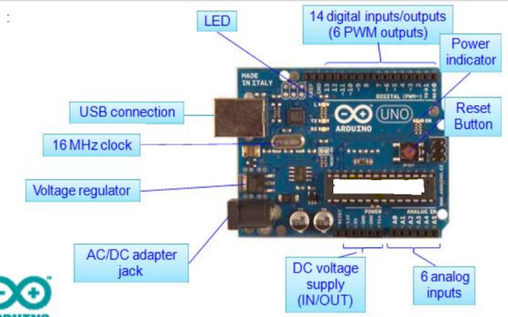

***ARDUINO BOARD:***

Arduino consists of both a physical programmable

Circuitboard (often referred to as a microcontroller)

and a piece of software, or IDE (Integrated Development Environment)

that runs on your computer, used to write and

upload computer code to the physical **board**.

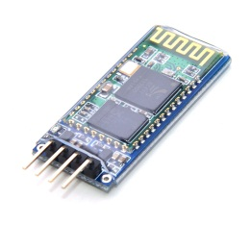***BLUETOOTH:***

A Bluetooth module is usually a hardware component that provides a wireless product to work with the computer; or in some cases, the Bluetooth may be an accessory or peripheral, or a wireless headphone ,or other product (such as cellphones can use.)

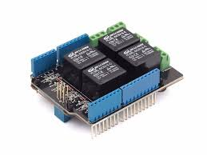***RELAYS:***

A relay is an [electrically](https://en.wikipedia.org/wiki/Electric) operated [switch](https://en.wikipedia.org/wiki/Switch). Many relays use an [electromagnet](https://en.wikipedia.org/wiki/Electromagnet) to mechanically operate a switch, but other operating principles are also used, such as [solid-state relays](https://en.wikipedia.org/wiki/Solid-state_relay). Relays are used where it is necessary to control a circuit by a separate low-power signal, or where several circuits must be controlled by one signal, but why are we using relays in this project? The answer is that AC is alternating current 220v which powers the ac lights. Arduino cannot control high volt n amp, but a relay can do this job, which is the sole design of it, so we are using relay as switch to control high power devices.

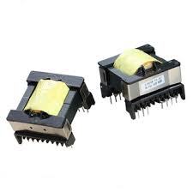  
***TRANSFORMER:***

A **transformer** is an electrical device that transfers electrical energy between two or more [circuits](https://en.wikipedia.org/wiki/Electrical_network) through [electromagnetic induction](https://en.wikipedia.org/wiki/Electromagnetic_induction). A varying current in one coil of the transformer produces a varying magnetic field, which in turn induces a [voltage](https://en.wikipedia.org/wiki/Voltage) in a second coil.

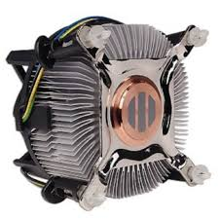***Heat Sink:***

Heat sink is used in case to control the heat if our arduino board starts burning then it will cool down the whole circuit.

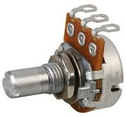***Potentiometer:***

Then we have used potentiometer it is used to resist the flow of current manually when we feel the voltage is not well then we use potentiometer in order to control the flow of unnecessary current to save our components from burning.

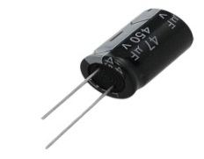***Capacitors:***A **capacitor** is a [passive](https://en.wikipedia.org/wiki/Passivity_(engineering)) [two-terminal](https://en.wikipedia.org/wiki/Terminal_(electronics)) [electrical component](https://en.wikipedia.org/wiki/Electronic_component) that stores electrical [energy](https://en.wikipedia.org/wiki/Energy) in an [electric field](https://en.wikipedia.org/wiki/Electric_field) .

***Resistor:***

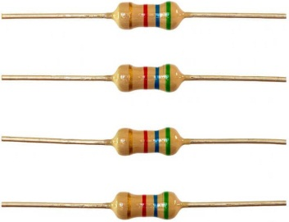A resistor is a [passive](https://en.wikipedia.org/wiki/Passivity_(engineering)) [two-terminal](https://en.wikipedia.org/wiki/Terminal_(electronics)) [electrical component](https://en.wikipedia.org/wiki/Electronic_component) that implements [electrical resistance](https://en.wikipedia.org/wiki/Electrical_resistance) as a circuit element. In electronic circuits, resistors are used to reduce current flow, and adjust signal levels.  When building your Arduinoprojects, you use resistors to limit the amount of current going to certain components in the circuit, such as LEDs and integrated circuits.

***TSOP:***

TSOP1738 is a very commonly used IR receiver for PCM remote control systems. It has only 3 pins, Vcc, GND and Output. It can be powered using a 5V power supply and its active low output can be directly connected to a microcontroller or microprocessor.

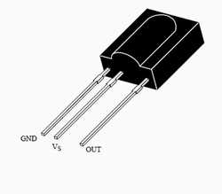

***Software Components:***

* **Arduino IDE (using C Language )**
* **Android Bluetooth Application**

***ARDUINO IDE:***

The Arduino Integrated Development Environment - or Arduino Software (IDE) - contains a text editor for writing code, a message area, a text console, a toolbar with buttons for common functions and a series of menus. It connects to the Arduino and Genuine hardware to upload programs and communicate with them.

**CODE OF OUR PROJECT:**

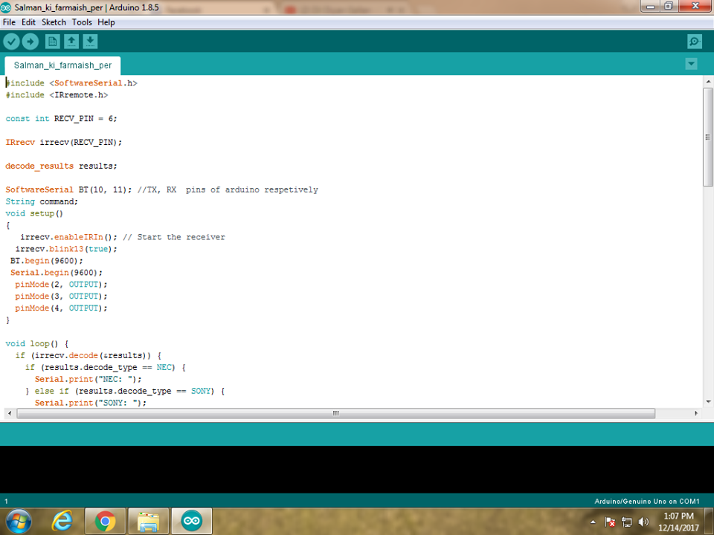

***ANDROID BLUETOOTH APPLICATION:***

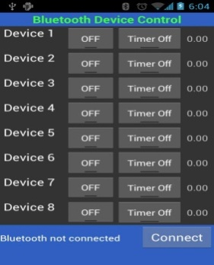The application framework provides access to the Bluetooth functionality through the Android Bluetooth APIs. These APIs let applications wirelessly connect to other Bluetooth devices, enabling point-to-point and multipoint wireless features.

***Circuit:***

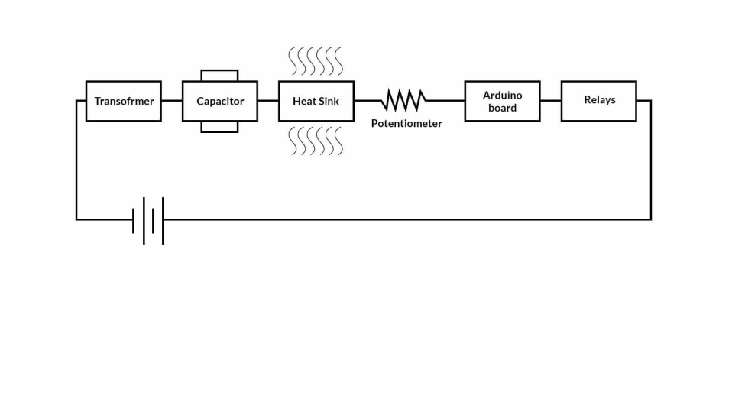

***Results:***

The current passes through the transformer which converts AC current to DC current .Current then passes through the capacitor, purpose to save the energy and powers the Arduino board .Heat sink is attached to the arduino board in order to protect the arduino board from heat up .The current passes through the transformer which converts AC current to DC current .Current then passes through the capacitor, purpose to save the energy and powers the Arduino board .Heat sink is attached to the arduino board in order to protect the arduino board from heat up .Bluetooth and Bluetooth and TSOP is connected to the arduino board which receives the data sent by the Bluetooth terminal App through Android Smart Phone or from the remote control .Relays are also connected to control the circuit .There are 3 relays present in the circuit in which we set up the pins 1 ,3 and 5 for the ON switch and pins 2 ,4 and 6 for the Off switch .A bulb is connected to the relays and turn on when receives the signals from the arduino board .

***Conclusion:***

The system as the name indicates, ‘Android based home automation’ makes the system more flexible and provides attractive user interface compared to other home automation systems. In this system we integrate mobile devices into home automation systems. A novel architecture for a home automation system is proposed using the relatively new communication technologies. The system consists of mainly three components is a Bluetooth module, Arduino microcontroller and relay circuits. Bluetooth is used as the communication channel between android phone and the Arduino microcontroller. We hide the complexity of the notions involved in the home automation system by including them into a simple, but comprehensive set of related concepts. This simplification is needed to fit as much of the functionality on the limited space offered by a mobile device’s display.